

Project Report

Event Sphere

CONTENTS

1. Introduction
2. Proposed Solution
3. Purpose Of the Document
4. Who can use this Document?
5. Scope Of Project
6. Constraints
7. Functional Requirements
8. Non-Functional Requirements

­­

**Team Members**

**SFC-CODE AVENGERS**

|  |
| --- |
| M.Taqi Adeem |
| Syed Mehdi |
| M.Faiez |
| Raheel |



# 1. Event Sphere

C

ollege campuses are full of life, with numerous events, workshops, seminars, and cultural programs taking place throughout the academic year. However, managing these events manually often results in confusion, miscommunication, and a lack of proper coordination among participants, organizers, and administrators. To address these challenges, **EventSphere** has been developed as a centralized web portal that simplifies and streamlines the entire college event management process.

The platform allows participants to easily browse upcoming events, register online, and manage their own participation records. Organizers can create and manage events, track the number of participants, and update event information in real time. At the same time, administrators have complete control over user roles, event approvals, and platform-wide activity, ensuring everything runs smoothly and securely. By offering a structured and efficient way to handle college events, **EventSphere** not only reduces the workload for organizers and admins but also enhances student engagement and improves communication across all levels.

In short, **EventSphere** fills a critical gap in how college events are handled, transforming a traditionally manual process into a smart, user-friendly digital experience.

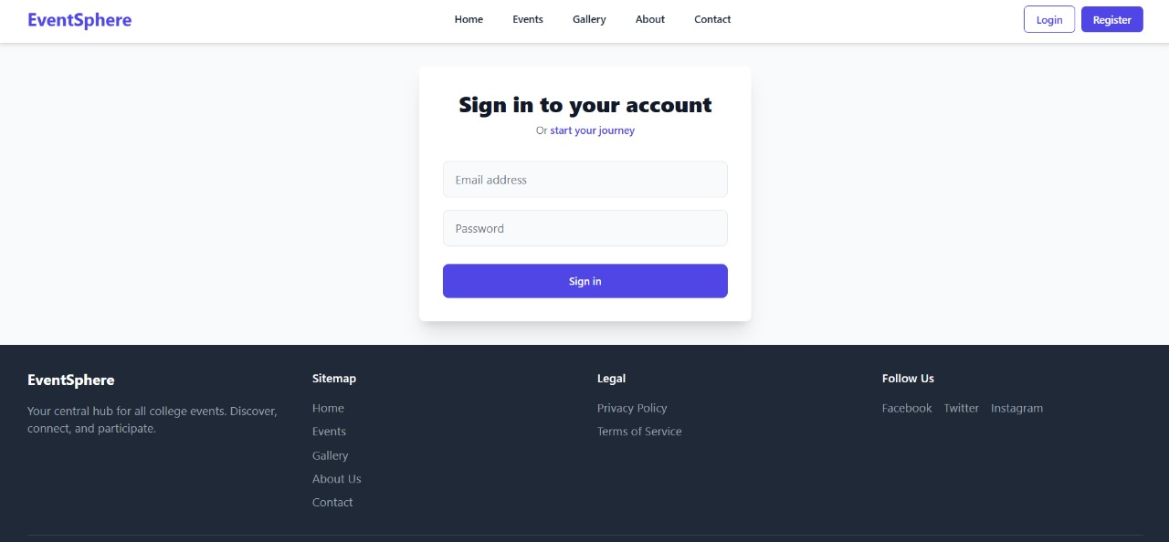



# 2. Sign In & Sign Up

The **login page** of **EventSphere** provides secure access for participants, organizers, and admins, with role-based redirection to their respective dashboards. It includes fields for email and password, a "Sign in" button, and a link to register. **Visitors** can also explore events and browse the website without logging in. A navigation bar and footer ensure easy access to all main sections and resources.

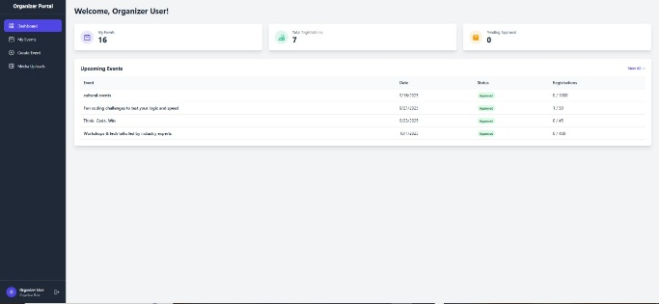 Each student’s progress can be viewed and tracked by students themselves and their parents/guardians.

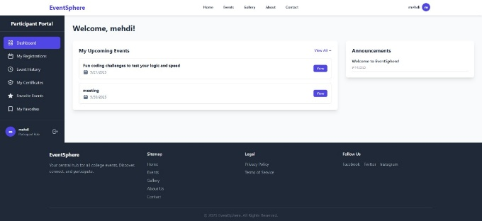

**ORGANIZER DASHBOARD**  **PARTICIPANT DASHBOARD**

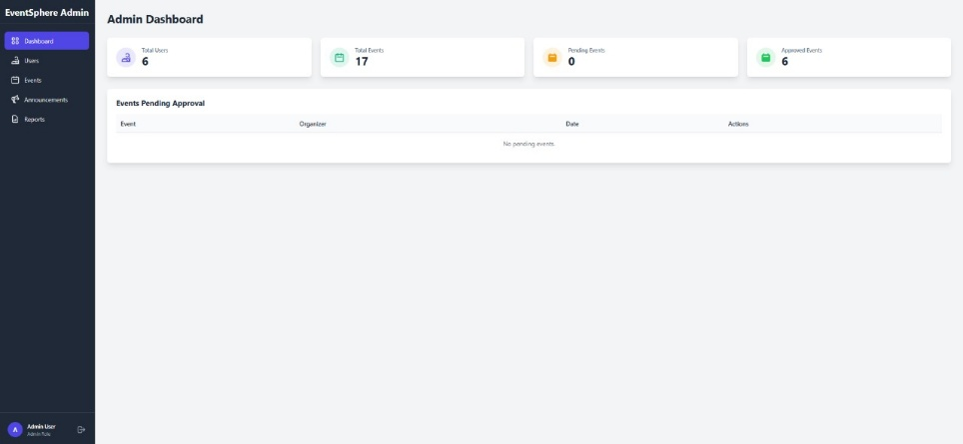



**ADMIN DASHBOARD**

# 3. Dashboards

**1. Participant Dashboard:**  
This dashboard allows participants to view all available events, register for them, and track their participation status. Users can also update their personal profiles and cancel event registrations if needed. It provides an easy-to-navigate interface focused on event discovery and personal management

**2. Organizer Dashboard:**  
Organizers use this panel to create, manage, and update events. They can view participant lists, monitor event status, and communicate important updates. The dashboard helps streamline event planning and execution with tools tailored to organizers’ needs.

**3. Admin Dashboard:**  
The admin dashboard offers comprehensive control over the entire platform. Admins can manage users (participants and organizers), approve or reject events, oversee all activities, and handle site-wide settings. This dashboard ensures smooth operation and governance of EventSphere.



# 4. Who can use this Document?

* Stakeholders of the portal
* Developers of the portal

# 4. Scope of Project

I

t provides an engaging student experience with a single point of access and hub to all applications, information, and content. One of the biggest obstacles that a student portal removes is the number of information silos found across colleges and universities today. The web portal will be a responsive and visually appealing website to be used by individuals (Students/Teachers/Parents/Guardians.)

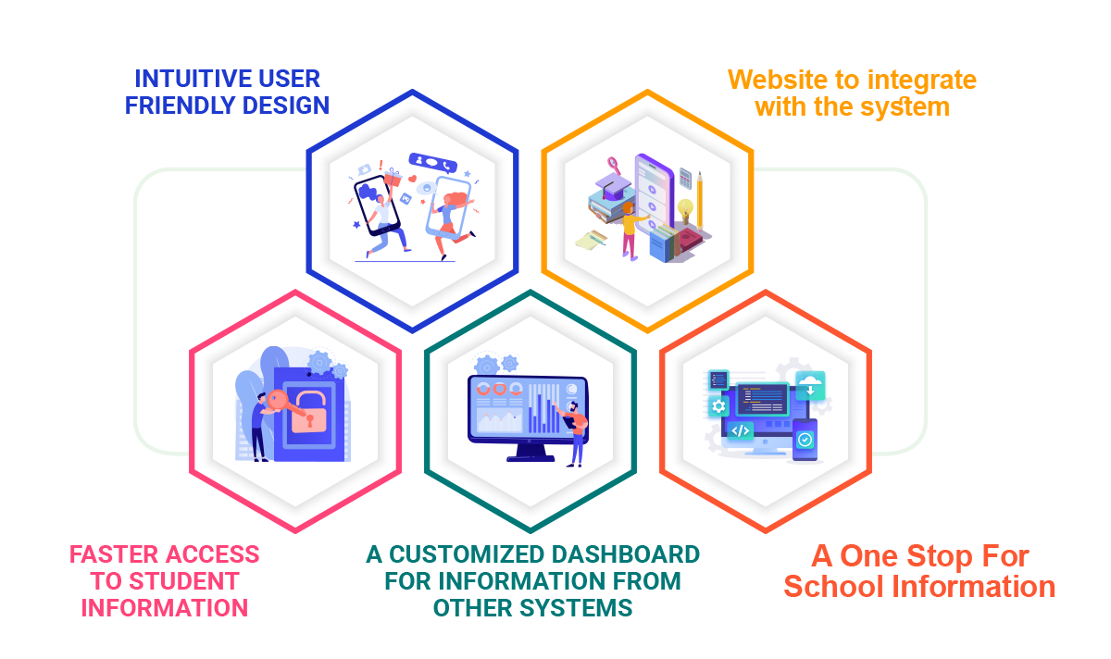

# 6. Constraints

C

onstraints also known as a limitation or restriction. The Web Portal will not have any facility to store information on the server. Information can be fetched from pre-populated JSON or TXT files and displayed; however, information cannot be written to the files from within the portal.

­­­­­­­

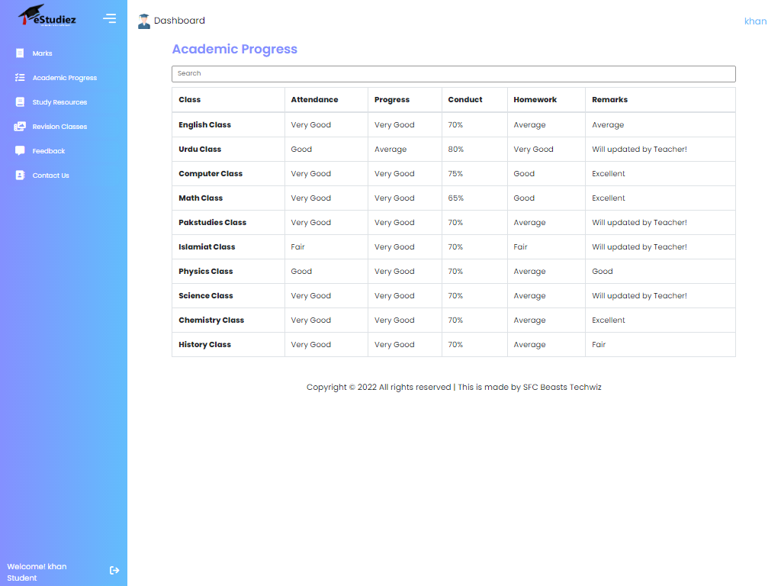

# 7. Functional Requirements

The portal is designed as a Single-Page-Application and responsive Website with a set of pages and menus that represent choice of activities to be performed. The pages, menus, and other visual elements are designed in a visually appealing manner with attractive fonts, colors, and animations. All of these are laid out in a responsive manner.

* **Menus and Web Page Functionality:**
* **Welcome Message:**

The home page accepts first name from the user and displays a personalized name. At the top corner, the user's first name is displayed for the entire duration that the portal is loaded. The login page also accepts category of user in the form of radio button selection. Based on selection, respective page and menus will be displayed. Refer the Sitemap section to see sample menus.

* **For Students:**

Marks that they have scored in internal tests conducted by teachers are displayed in a table. Academic Progress menu option displays the gradual progress in various tests across the year in the form of table data. Study Resources menu option displays a table containing links to Videos, and additional textbooks. Revision Classes menu option contains display information pertaining to extra classes for revision purposes. Date and time of classes are displayed there. Contact us page will display list of phone numbers that students can call in case they require general assistance.

* **For Teachers:**

Teachers can update marks that students have scored in internal tests conducted. This is done through a form. These marks are not stored anywhere and will not reflect on the student page as that functionality is beyond the scope. Academic Progress menu option will enable teachers to update the gradual progress in various tests across the year. The data for this is accepted via form. Add Study Resources menu option is enabled teachers to add links to external sites, and additional textbooks. Revision Classes Updating accepts date and times for extra classes for revision purposes.

* **For Parents/Guardians:**

They can view marks and academic progress of their wards. Helplines will display list of phone numbers that parents/guardians can call in case they require general assistance.

* **Feedback and Contact Us**

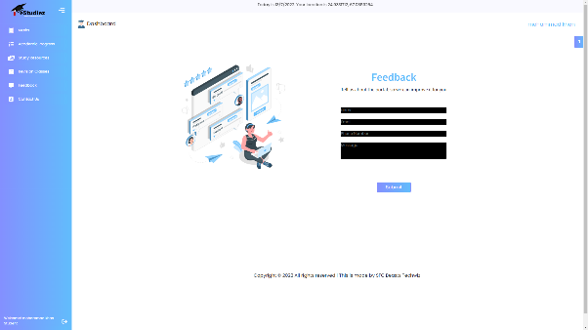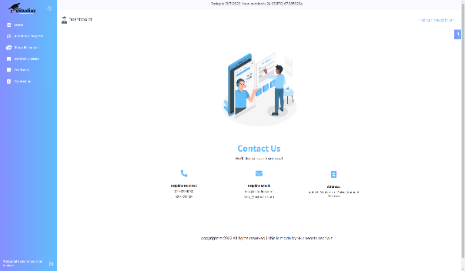These menu options have common functionality for all category of users regardless of whether they are students, teachers, or parents/guardians. Feedback menu option should enable users to provide their feedback about this portal through a feedback form. Contact Us menu option should enable users to contact the creators of the portal. An email id can be displayed here for contact information. Over and above this, the portal should implement following functionalities:

* Display a continuous scrolling ticker at the bottom of the page with current date, time, and location (hint: Use geolocation features of HTML5).
* Display a visitor count at the top right corner of the page beside a logo image.
* Menu options should change color on hover and also after clicking.
* Fade-in and fade-out options can be used for the menus.

# 8.Non-Functional Requirements

There are several non-functional requirements that should be fulfilled by the Website, henceforth called the 'system'. *The system should be*:

* **Safe to use:**

The system does not result in any malicious downloads or unnecessary file downloads.

* **Accessible:**

The system is clear and legible fonts, user-interface elements, and navigation elements.

* **User-friendly:**

The system is easy to navigate with clear menus and other elements and easy to understand.

* **Operability:**

The system operates in a reliably efficient manner.

* **Performance:**

The system demonstrates high value of performance through speed and throughput. In simple terms, the system is fast to load and page redirection is smooth.

* **Capacity:**

The system supports large number of users.

* **Availability:**

The system is available 24/7 with minimum down time.

* **Compatibility:**

The system is compatible with latest browsers